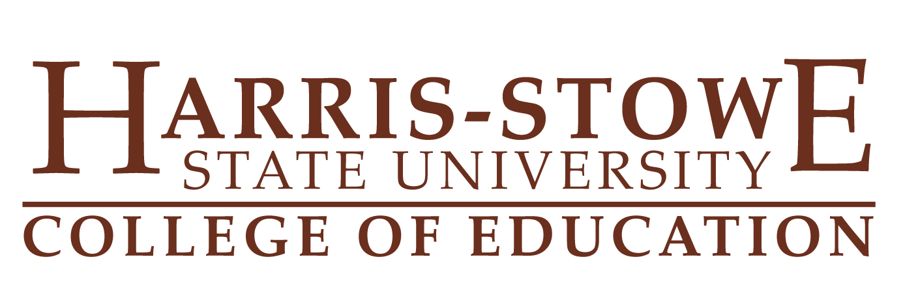
October 4, 2013

Report from College of Education Council

On Friday, September 15, 2013 the College of Education Council met in Room 208 of the Henry Givens Administration Building. Present were Dr. James Harden, Mr. Robert Ealy from Arts and Sciences, and Dr. Veola Martin. A brief overview of occurrences in the College of Education were shared with Mr. Ealy and a brief discussion on the changes proposed in some of the General Education courses as they would affect College of Education.
After the briefing, the meeting was adjorned.

Submitted,
Veola P. Martin
Veola P. Martin, Ed.D., Interim Dean
College of Education
Harris-Stowe State University

